**Arduino Based CubCar (Pinewood Derby) Timer**

I have been building Raspberry PI based cubcar timers for a number of years, and they can do a lot

1. Store results in a database
2. Use and RFID tag reader for tracking cars and fully eliminating paper
3. Can support running full applications including a GUI.

but they have some drawbacks:

1. Raspberry Pi’s are getting very expensive. A pi4 will run at least $100.00.
2. Setting up a Pi is an involved process – Can be an intimidating process
3. Configuring the timers and running races on the Pi’s requires a certain level of Unix skills

As a result I have built a next generation of cubcar timers based around an inexpensive Arduino Nano. While lacking in overall computing horsepower compared to a pi they are adequate to get the job done and can be built for less than $45.00 and after initial setup they require no computing skills to run them.

You have two options for lights on the track. Using LEDs with a shift register or using a WS28XX LED Strip. If using LEDS these are the parts that are needed for lighting:

|  |  |  |
| --- | --- | --- |
| **Item** | **Price** | **Notes** |
| 2 – 74HC595 Shift Registers | Aliexpress sells for 2 for $2.00 | Not needed if using LED Strip |
| 10 or 17 – 300 Ohm Resistors | Aliexpress sells in assortment pack for $5.00 | Only need 1 if using LED Strip |
| 9 or 16 – Colored LEDs (3 or 4 Red, 3 or 4 Yellow, 3 or 4 Blue, 3 or 4 Green etc) 5mm | Aliexpress sells in assortment kit for $3.50 | Not needed if using LED Strip |
| 14 Over Track WHITE LEDS 5mm |  | Not needed if using LED Strip |

**OR** If using an LED strip then the following is what you are looking for:

|  |  |  |
| --- | --- | --- |
| **Item** | **Price** | **Notes** |
| WS2812B 1 Meter High Density Lights | 8.99 | Will need to cut the LED strips into two, one for indicating race winner and one for illumination of the track |

The LED Strip provides the benefit that it can be programmed to light up different colors & patterns to make it more visually interesting. Also requires fewer parts to source, buy and install. However Light Strips can be finicky to work with and require careful cutting and installation and may not be as visible across a large room as the domed LEDS are.

**Additional Parts**

|  |  |  |
| --- | --- | --- |
| **Item** | **Price** | **Notes** |
| 1 – 20x4 I2C LCD display | 6.00 | Make sure it comes with i2c back piece. |
| 1 – Arduino Nano | 4.99 |  |
| 6 – 10K Resistors | 4.99 | Assortment Pack (May be covered in LEDs above) |
| 1 – PCB or Proto Board | 1.00 |  |
| 1 – Push button (Momentary) | .25 |  |
| 1 – Start Switch | .50 |  |
| 4 –LDRs | 2.99 | See notes below about LDRs |
| 1 – RS232 9 pin connector | .99 | Optional, can use any type of connector |
| 1 – Two conductor speaker wire for start switch | 3.00 |  |
| Various Dupont Jumper Wires |  | Can also solder direct to the board |
| 1 – RCA Connector for Start Switch | 1.00 | Optional, can use any type of connector |
| Dupont Headers | 1.00 | Optional, makes troubleshooting easier |
| DC-DC 12V to 3.3V 5V Step-Down Power Supply Module DC-DC Voltage Converter Multi-Output Buck Power | 3.00 | Optional  Screen + LEDS draw a lot of power, Buck converter accepts 7-12 V input and outputs both 5 & 3.3V. If Screen fades or LEDs are too dim then Buck Converter powering Screen & LEDs may be needed. |
| Power Supply | 3.00 | Needs depends on whether you are using a buck converter or not. |
| Enclosure |  | 3D printed or make your own. |
| Stand |  | Can be readily made out of just about anything. |

**PCB**

I have designed PCB boards to make assembly of the timers much easier. These boards will work with 2,3,4 lane tracks.

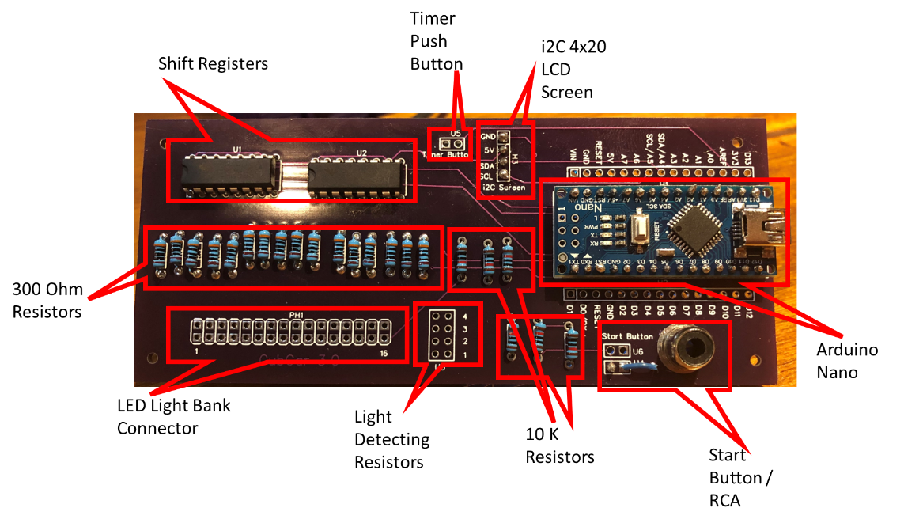The PCB was conceived to be mounted on the back of the timer enclosure so that the nano ports and the start button RCA connector are accessible.

The Nano can either be mounted so that it is removable or soldered directly into the board.

As some of the wires will be internal to the timer enclosure the board is designed so that connecting wires can be soldered in from either side. (Note: You can solder the Arduino or the shift registers backwards if you put them on the wrong side of the board, so there are guides to help with chip orientation.

Over track LEDs

Powering the Unit

**LDR’s – (Light Detecting Resistors)**

I originally bought a 20 pack of assorted LDR’s from amazon and discovered that only a few of them actually work well for this purpose. (Some were too sensitive, some needed way too much light to dark to actually trigger, some I could never get to trigger.) You can either buy a big assortment pack and trial and error your way through or buy one of the two types listed below.

Gl5549

Gl5537

(Note: Even if you buy one of these two types you will want to test them prior to installation as they have a lot of variability in their functionality, have seen up to 20% duds in a package)

**Understanding the Start Switch**.

On the track you will want to source a button something like this which is closed when cars are being loaded and opens when the cars are released. You will want to rig the track so that you don’t jiggle switch too much or you wont get reliable track start and stops.

The program will stop and wait for 2 events on the start button at least 1 second apart. (Button Push Event, followed by a button release event).

You will need a length of cable (speaker wire or doorbell wire) that runs the length of the track.

My start switch cable had an RCA jack on it, so that is what I used, but you can use any sort of connector you can get to connect the start switch to the timer. There is a spot on the PCB that a panel mount RCA connector can be attached easily.

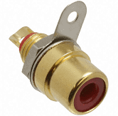

**Enclosures & Stand**

I have designed enclosures which can be 3D printed which consist of 3 pieces. A backplane, the box itself and a bezel for the screen. All the designs are freely available. The designs I printed were specific to a 3 lane track but can be readily modified for a 2 lane or 4 lane track.

There is a slot in the bezel for a stand so that the timer can be mounted above the track. The dimensions should allow for a narrow paint stick to be inserted without interfering with any of the electronics inside.